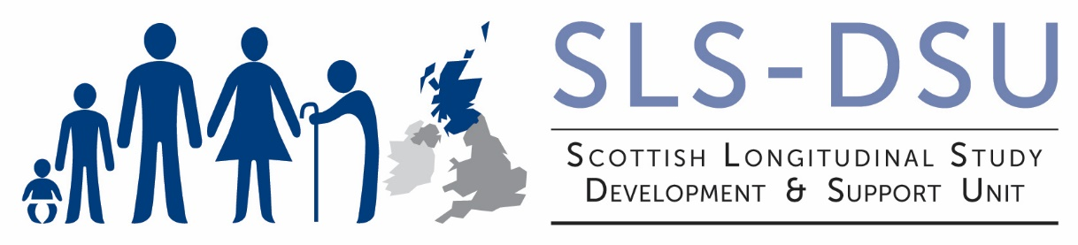

BECOMING AN APPROVED RESEARCHER

The aim of reviewing researchers to be an Approved Researcher is to establish that there is a public benefit in allowing this person access to sensitive data and that evidence exists that s/he will know how to deal with it and will do so responsibly.

Each individual researcher who wishes to access sensitive data will need to complete the Approved Researcher form and MUST sign the declaration. A separate application must be made for each new project, even if the researcher is already an Approved Researcher on another project.

The completed form should be sent to sls@lscs.ac.uk

Once the SLS team have received your completed forms and signed declaration they will decide whether you satisfy the published criteria to obtain Approved Researcher Status.

The SLS Project Manager will then notify you of the outcome of the decision. If it is necessary to refuse your application then the reasons will be included in a letter.

The SLS aim to process applications to be accredited as an Approved Researcher as quickly as possible and, usually, within three weeks.

Your Privacy

The information you provide on this form will be treated in the strictest confidence. An electronic copy of this form will be securely stored with NRS and the SLS-DSU. A hard copy will be securely stored in the SLS-DSU. For further information on how your data is used, see:

https://www.nrscotland.gov.uk/record-keeping/legislation/primary-information-legislation/data-protection
https://sls.lscs.ac.uk/more/privacy-statement/

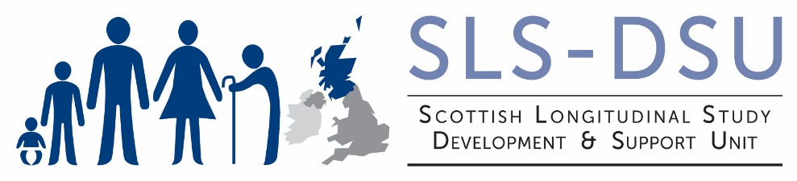

Application for Accreditation as an Approved Researcher

The information you provide on this form will be used to consider whether you meet the criteria needed to be accredited as an Approved Researcher. A researcher is deemed 'Fit and Proper' when:

- They have demonstrated the appropriate knowledge and experience necessary for handling potentially disclosive personal information;
- They have provided satisfactory evidence supporting their application that illustrates their professionalism and technical competence to carry out research on potentially disclosive personal information;
- They have demonstrated a commitment to protecting and maintaining the confidentiality of data during the creation of outputs and publications.
Your Details:
These details will be used to enable NRS and the SLS-DSU to contact you. If you are working as part of an organisation, such as a business, university or charity, please complete the details of that organisation. If you are researcher not affiliated to any particular employer the details are likely to be your personal ones and you should write ‘None’ next to Institution.

Title
Name
Position
Organisation
Address
Telephone
Email Address
Date of last Safe Researcher Training (SRT)
Date of last Application for Approved Researcher Status
ORCID ID (if applicable)

Your Experience:
Outline your experience of research that has involved handling potentially disclosive personal information. Any details you provide should focus on relevant experience and should illustrate your suitability to use personal information.
Information and its source
Research title and date
Your specific involvement
Statistical use of the information
Measures used for disclosure control and information security
Other relevant information
Include any other information you feel would help to demonstrate your experience in handling potentially disclosive personal information.)

Your Professionalism:
Provide membership details of professional bodies.
Membership of professional bodies can include associations or societies. Current details are of more interest but you may provide details of past memberships where you consider them appropriate.

1
2
3

Provide examples of your contribution towards public policy or journal publications
Include details of publications that provide evidence of your meeting the published criteria. Electronic links would be helpful.

1
2
3

Include any other information you feel would help to demonstrate your professional competence.

Any other information for consideration:
If you feel that your application is insufficient when matched against one or more criteria then use this space to add any extra evidence you feel is relevant. If you have only limited evidence you should provide the name of a suitable referee. You must include any evidence which is relevant in any way.

Access to personal information as an Approved Researcher is conditional upon signing this Declaration.

By signing this Declaration, you are confirming

- the accuracy of any information you provide to support your application,
- your understanding of the conditions specified below,
- you will abide by any other requirements communicated to you by NISRA relating to this use of potentially disclosive personal information.

DECLARATION:

I declare that the personal information provided to me shall be kept secure and confidential according to the terms of any agreements with the National Records of Scotland.

I understand that:

- Personal information means information which relates to and identifies a particular person (including a body corporate). Information identifies a particular person if the identity of that person is specified in the information; can be deduced from the information itself; or can be deduced from the information taken with any other published information;
- NRS reserves the right to scrutinise any products or publications for disclosure control purposes before publication;
- I will be required to sign the Census Confidentiality Undertaking and may be liable to criminal prosecution under the Census (Confidentiality) (Northern Ireland) Order 1991 if I disclose this personal information to any other person;
- My lawful use of this information is only for the purposes of statistical research approved by the SLS Research Board as agreed in writing with NRS ;
- I am required to bring directly to the attention of the SLS assessment panel any matters or events that may affect my obligations under this declaration, my Approved Researcher accreditation, or any other matter in the written agreements relating to this use of personal information;
- I am authorised to access this personal information only when I receive from SLS a written and signed confirmation, and only until the end date in that written confirmation.
- I understand that Approved Researcher status will be granted for a period of two years and reviewed annually thereafter. In the case of provisional Approved Researcher status I understand that this will be granted for a period of one year and reviewed annually thereafter.

Signed:

Print Name:

Date:

Office Use Only Researcher Number: Application Number:

Decision made by:
Decision date:

grant ‘Approved Researcher’ status
grant provisional ‘Approved Researcher’ status
request further information
deny ‘Approved Researcher’ status

Researcher notified of decision:

Glossary of Terms

Personal information | 'Personal information' is defined as 'information which relates to and identifies a particular person (including a body corporate)
Fit and proper person | A fit and proper person is one who is able to demonstrate, to the satisfaction of SLS, that he/she:  - has the appropriate knowledge and experience necessary for handling confidential personal information.  - has provided satisfactory evidence to support their application that adequately illustrates their professionalism and technical competence to use the data requested in the research proposal  - is committed to protecting and maintaining the confidentiality of the data and their technical and physical security, during their use of the data and the creation of outputs and publications arising from their analyses.
Confidential | Confidential ‘personal information’ is information  - that specifies the identity of a particular person (including a body corporate)  - From which the identity of a particular person can be deduced, or  - From which the identity of a particular person can be deduced when taken together with other published information

