

SLS APPLICATION FORM

The Longitudinal Studies Centre – Scotland (LSCS) is a Scottish centre of excellence in the creation and use of longitudinal data. It is responsible for the Scottish Longitudinal Study (SLS).

Please look at the SLS-DSU website (http://sls.lscs.ac.uk/guides-resources/step-bystep-guide-to-accessing-sls-data-1/) for steps involved in accessing SLS data. The completion of this form is step four.
Your Privacy

The information you provide on this form will be treated in the strictest confidence. An electronic copy of this form will be securely stored with NRS and the SLS-DSU. A hard copy will be securely stored in the SLS-DSU. For further information on how your data is used, see:

https://www.nrscotland.gov.uk/record-keeping/legislation/primary-information-legislation/data-protection
https://sls.lscs.ac.uk/more/privacy-statement/

PART A: USER AND STUDY DETAILS

Section A1 Application details
Study title

Head of proposed study
Title: | Name:
Position:
Organisation:
Address:
Telephone: |  | Fax:
Email:

Names and contact details of all researchers who will be using the data
 | Name | University/ organisation | Telephone | Email | Main Contact (please tick)
1
2
3
4
5
6

Expected duration of project (dd/mm/yyyy)

From:

To:

Please ensure that you propose a realistic end date. This can be amended later if circumstances change.

Section A2 Funding details
It is not necessary to have funding to conduct research with the SLS, as the data are freely available to academic researchers. However, many researchers request funding to undertake projects using the SLS.

Source of funding (if applicable)
Is funding confirmed? (if yes, tick box)

Section A3 Background and aims of study

The information given here in section A3 will be published on the SLS-DSU website at: http://sls.lscs.ac.uk/projects/ if the project is approved

A3.1 Explain the precise aims of your study (up to 250 words)
This should describe the specific aims of your project, and must include the hypothesis that you hope to test and/or your detailed research questions.
Type or paste your text in the box below.
A3.2 Ethical considerations (up to 100 words)
Please detail any ethical issues which may arise from your project.

Academic users: please also state whether you have obtained ethical approval for your study, or if you plan to seek ethical approval from your institution. Note that if you require the linkage of any health data and will apply to Public Benefit and Privacy Panel (PBaPP) for Health and Social Care you must have ethical approval. Please note this subsection will not be included on the SLS-DSU website.

A3.3 Give an account of the background to your planned study (up to 400 words)
This should include a brief summary of what is known to date about your chosen topic and what and how your study contributes to what is known to date.

A3.4 References

A3.5 Explain why the SLS data are useful for this study (up to 200 words)
(You may wish to explain why other datasets are not as useful as the SLS for the study you are planning)

Section A4 Dissemination and Impact
A4.1 Please indicate how you will publicise and disseminate the findings of your proposed study and identify any deadlines. (e.g., plans for journal papers or conference presentations)

Would you be happy to give a presentation if requested to Scottish Government?

Yes No

A4.2 Please indicate how your research will have impact both for academia and for a wider audience (e.g., Government and third-sector bodies). Give some idea of exactly who might benefit from the work, and the steps you plan to take to achieve this impact. For example, if your work could influence policy-making, you might plan to write a research briefing for a Government department, give a presentation to your target audience, or offer advice on a consultancy basis.
Your Support Officer can advise you on completing this section. (up to 200 words)

PART B: SPECIFYING EXTRACT AND PRACTICAL ARRANGEMENTS

Please complete this section of the form with the help of your Support Officer.

Section B1 Study population
B1.1 Provide a description of the population selected for the study
(For example, all male SLS members enumerated at the 1991 and 2001 Censuses and aged 16 – 64 years at the 1991 Census).
If your project requires more than one sample (for example, non-members resident with SLS members at Census time) please describe the samples separately.

B1.2 Estimated sample size (ask your Support Officer)
If your project requires more than one sample please give these details separately.

What files will the data be drawn from?
(See Annex A for an overview of the SLS study structure and brief description of the data in each of the SLS files)

SLS Core datasets
Census data | Vital events data |  | Event dates
1991 | Births of SLS Member |  | from | to
2001 | Births to SLS Member |  | from | to
2011 | Stillbirths |  | from | to
 | Infant Mortality |  | from | to
 | Marriages |  | from | to
 | Widow(er)hoods |  | from | to
 | Death |  | from | to
Other SLS data
Immigration |  |  | from | to
Emigration |  |  | from | to
Ecological data (table ECOLOGICAL)
Education data (2007 onwards)
School Census
School Attendance |  | School Exclusions
SQA Attainment |  | SQA Qualifications
Health data (variables on request only)
PBaPP application attached
PBaPP application being prepared
Hospital admissions SMR01
Cancer registrations SMR06
Mental Health Inpatient & Day Case SMR04
Maternity Inpatient and Day Case SMR02
Outpatient Attendance dataset SMR00
Child Health data

Other health data - please specify: _______________________________________

What variables will you need?
Please list in more detail the variables you need
This section should be completed using the SLS Data Dictionary, which can be found at: http://sls.lscs.ac.uk/variables/. The tables in Annex B (a summary of the most widely used variables and general information on selecting variables) may also be helpful. If you are not sure of the exact variables you want, give a broad indication of the type of variables you are likely to use and discuss this in more detail with your SLS Support Officer. Full details will be required before data extraction can begin. Please note that a project with over 60 variables in total is considered a large project. It may also be useful to consider the restriction levels of variables in order to operationalize them for your research. You can either check this with your Support Officer or see Annex A for an overview of the restricted variable levels.

If your project requires more than one sample (for example, non-members resident with SLS members at Census time) please list these variables in separate tables.

SLS members

Table name | Variable name | Short description | Restriction  level

If you need more variables, please attach a separate sheet with a similar table.
SLS non-members (i.e. people living with SLS members at Census time)

Table name | Variable name | Short description | Restriction  level

If you need more variables, please attach a separate sheet with a similar table.
B1.3 Derived variable(s)
You may wish to specify your own derived variables (i.e. variables that do not exist already on the SLS database, which cannot readily be created from existing variables due to restriction levels). List the input variables to be used in the derivation and, where possible, show how the variable will be derived.
As an example, if an SLS member is living with a partner (cohabiting/marriage) in both 1991 and 2001, we could use the full date of birth for the partner at each point in order to check whether it is the same person. This would create a 0/1 indicator: 0=different partner, 1=same - based on partner's DOB.

B1.4 Independently sourced data
If you wish to link independently sourced data to your SLS sample, please describe the data (including source) and the geographical level and time point (e.g. 1991 postcode, 2001 output area, 2011 datazone) at which you would like to link it below. Please also indicate the format that you will provide the data in.

B1.5 Briefly explain the variable/data selection for this study (up to 300 words)
- Users of ISD health data: please explain in general why these variables are required for the study. If you have not completed a PBPP form please indicate the sources that may be requested.
- Users of weather and/or pollution data: please specify the frequency of (e.g. monthly, annual, day of Census) and geographical level at which you require the data.
- All users: please explain broadly why each of the SLS datasets selected is required, and if a large number of variables requested, in broad terms why they are necessary.
(For example: if you have requested the Stillbirths, Infant Mortality data and have not discussed the need for this elsewhere in the application form, please state briefly why this information is necessary to answer your research question. Or if Marriages and Widow(er)hoods or Immigration/Emigration data requested explain briefly why it is essential)

Section B2 Service and access arrangements

Currently, there are two possible methods for accessing SLS data, as described on the SLS-DSU website (http://sls.lscs.ac.uk/guides-resources/accessing-sls-data/).
- Remote access will involve users submitting syntax files (command files). These will be run by SLS staff on the data extract that has been created for the user, and output will be returned to the user once it has been cleared.
- Or users may wish to visit the NRS Safe Setting room (Ladywell House, Edinburgh) and work alongside a SLS Support Officer. We do not supply individual-level data for users to analyse themselves outside the safe setting.

What outputs will you need from the Scottish Longitudinal Study?
 | SPSS | Stata | SAS | Excel | Other (specify):
In what format will you submit your command syntax?
What format do you require your results output to be in?

Safe Setting
Do you expect that you will you need to come to the NRS to analyse the data?
(If so, we will need to arrange such visits and will contact you about this as soon as possible)

Tick box if yes

This form should be EMAILED to your SLS Support Officer
Dawn Everington: D.Everington@ed.ac.uk
Zhiqiang Feng: zhiqiang.feng@ed.ac.uk
Lee Williamson: lee.williamson@ed.ac.uk
Lynne Forrest: lynne.forrest@ed.ac.uk

ANNEX A

Overview of the SLS study structure

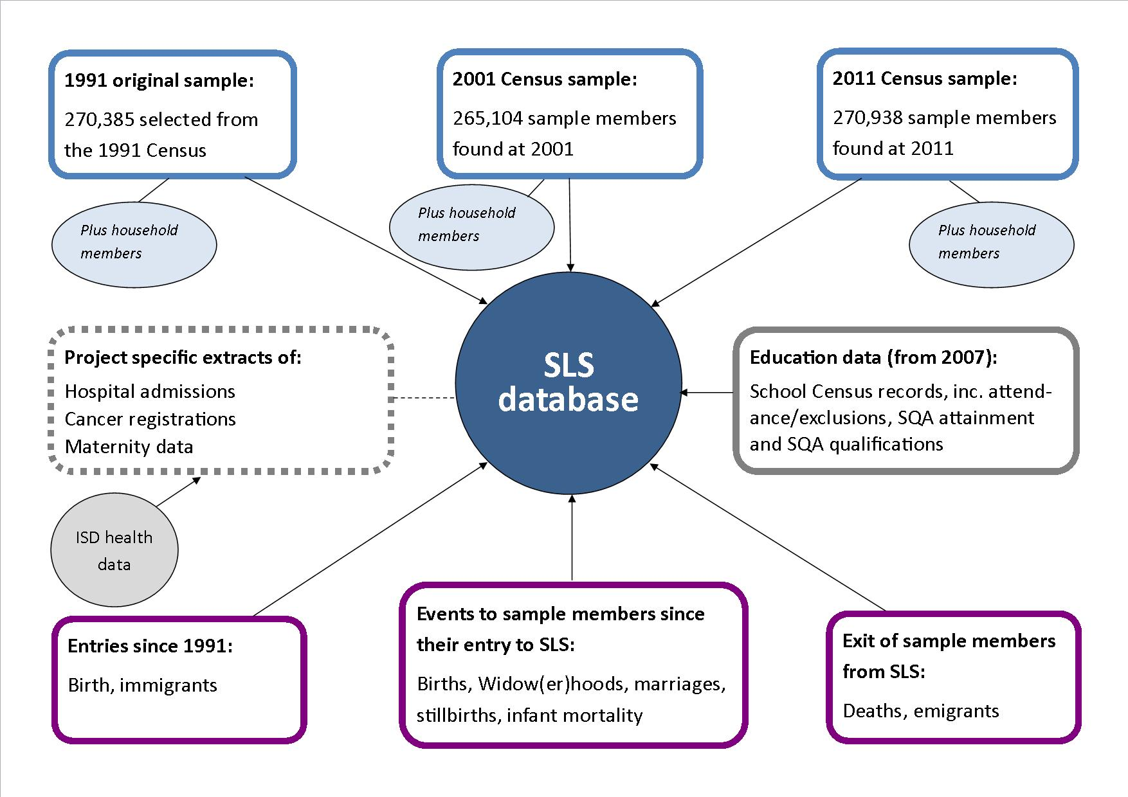

Overview of the SLS Restricted variables – 3 levels of restriction

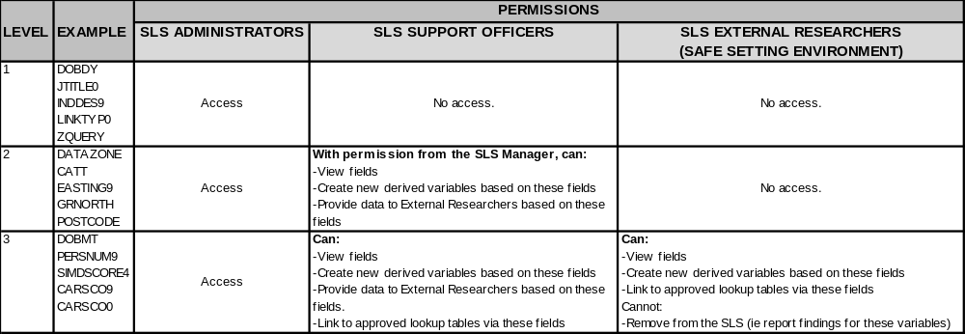

Data contained in the SLS Database for members and non-members
Source | Short Table name | Description
General | CORE | Core contains information from the source from where the SLS member first entered the SLS (i.e. birth, immigration, Census). File containing unique identifier for each SLS member, sex, year of birth, presence at Census & tracing indicators
1991 Census | 91MEMBER | 1991 Census person data on SLS members
1991 Census | 91NONMEMBER | 1991 Census person data on SLS non-members (people living with SLS members)
1991 Census | 91HOUSEHOLD | 1991 Census household data for SLS members and non-members
1991 Census | 91COMMUNAL | 1991 Census communal data for SLS members living in communal households
1991 Census | 91FAMILY | 1991 Census data on persons living in families
1991 Census | 91LSRELAT | 1991 Census data on relationships to SLS members in households
2001 Census | 01MEMBER | 2001 Census person data on SLS members
2001 Census | 01NONMEMBER | 2001 Census person data on SLS non-members (people living with SLS members)
2001 Census | 01HOUSEHOLD | 2001 Census household data for SLS members and non-members
2001 Census | 01COMMUNAL | 2001 Census communal data for SLS members living in communal households
2001 Census | 01LSRELAT | 2001 Census data on relationships to SLS members in households
2011 Census | 11MEMBER | 2011 Census person data on SLS members
2011 Census | 11NONMEMBER | 2011 Census person data on SLS non-members (people living with SLS members)
2011 Census | 11HOUSEHOLD | 2011 Census household data for SLS members and non-members
2011 Census | 11COMMUNAL | 2011 Census communal data for SLS members living in communal households
2011 Census | 11FAMILY | 2011 Census data on persons living in families
2011 Census | 11LSRELAT | 2011 Census data on relationships to SLS members in households
Vital Events | BIRTH | Births of new SLS members
Vital Events | DEATH | Deaths of SLS members
Vital Events | DEATH | Deaths of SLS members’ spouses
Vital Events | BIRTH | Live Births to female SLS members
Vital Events | BIRTH | Live Births to male SLS members
Vital Events | STILLBIRTH | Stillbirths to female SLS members
Vital Events | STILLBIRTH | Stillbirths to male SLS members
Vital Events | INFANT MORTALITY | Infant deaths to child of SLS mother
Vital Events | INFANT MORTALITY | Infant deaths to child of SLS father
Vital Events | MARRIAGE | Marriage of female SLS member
Vital Events | MARRIAGE | Marriage of male SLS member
--- | ECOLOGICAL | Area-based variables about deprivation, population density and urban-rural indicator
--- | IMMIGRANT | Immigrations of new SLS members from outside UK
--- | MIGRATION | Migrations of SLS members (into or out of Scotland)
--- | Education data  Tables H01 to H05 | Including: School Census, School Attendance, School Exclusions, SQA Attainment and SQA Qualifications
--- | POLLUTION | Pollution Variables
--- | WEATHER | Weather Variables

Other data available
For weather or pollution data please ensure that you specify the frequency of (e.g. monthly, annual, day of Census) and geographical level at which you require the data in section B1.4. Details of these variables can be found in the Weather Table (G03) and Pollution Table (G02) of the Data Dictionary.

For health data (including Cancer registrations SMR06, Hospital admissions SMR01 and Maternity Inpatient and Day Case SMR02) detailed information on the data, the timeline and all variables included is available from:
www.adls.ac.uk/find-administrative-data/introduction-to-nhs-scotland
Along with the downloadable ‘NHS Scotland PDF Pack’ (10.4M) from:
www.adls.ac.uk/wp-content/files_flutter/ISDPDFpack.pdf
Note that if any health data linkage is required you will have to apply to the Public Benefit and Privacy Panel (PBaPP) for Health and Social Care for approval first. The PBaPP form and Guidance Notes are available from:
www.informationgovernance.scot.nhs.uk/home/for-applicants
Your SLS Support Officer can advise you on applying to PBaPP and will help arrange an Electronic Data Research and Innovation Service (eDRIS) Research Co-ordinator for you. For more information on eDRIS please see: www.isdscotland.org/Products-and-Services/eDRIS/
ANNEX B

Key population selection variables

Description | Variable name | Table name
Unique identifier allocated to SLS member at entry to SLS | SLSNO | A01 / CORE
Year of birth | DOBYR  DOBYRT9, DOBYR9  DOBYR0  DOBYR1 | A01 / CORE  C10 / 91Member  C20 / 01Member  C30 / 11Member
Sex | SEX  SEXTEN9, SEX9  SEX0  SEX1 | A01 / CORE  C10 / 91Member  C20 / 01Member  C30 / 11Member
Age at 1991 census  Age at 2001 census  Age at 2011 census | AGETEN9, AGE9  AGEP0  AGEP1 | C10 / 91Member  C20 / 01Member  C30 / 11Member
Presence at 1991 census  Presence at 2001 census  Presence at 2011 census | HISCEN9  HISCEN0  HISCEN1 | A01 / CORE  A01 / CORE  A01 / CORE
Tracing indicators (way of entry into and out of the SLS) | TRACEIN  TRACEOUT | A01 / CORE
Indicator whether a person lives in a private household or in a communal establishment | 1991: RECTYPE9  2001: PERTYP0  2011: RESIDENCE_TYPE1 | C10 / 91Member and  C11 / 91NonMember  C20 / 01Member and  C21 / 01NonMember  C30 / 11Member and  C31 / 11NonMember
Relationship  (1991: of all household members to the head of household)  (2001: of all household members to one another)  (2011: of all household members to one another) | 1991: RELAT9  2001: RELAT0  2011: RELTSHIP1 | C10 / 91Member and  C11 / 91NonMember  C20 / 01Member and  C21 / 01NonMember  C30 / 11Member and  C31 / 11NonMember
Relationship to the SLS member | LSRELAT9  LSRELAT0  LSRELAT1 | C15 / 91LSRELAT  C25 / 01LSRELAT  C35 / 11LSRELAT

Useful info for selecting variables and selecting a sample:

1991 Census ‘SLS recoded variables’
For 1991 Census given this was before the advances in machine readable forms and was coded by hand transcription, the ‘difficult to code’ Census information (e.g. occupation) was only captured electronically for 10% of the population and the SLS-DSU needed to transcribe these data for the remainder of our sample. In fact we transcribed the information for our entire sample, to allow us to check our results against the original transcribing for 10% of the cases and this procedure revealed some coding errors in the original Census transcription/coding. Both the original Census (10%) and the SLS recoding (100%) are available in the Data Dictionary. As a general rule we recommend that users select the variables with the ‘SLS recoded variables’ in the description that were recoded by the SLS-DSU, these can be identified by ‘t9’ or ‘ten9’ at the end of the variable name. For example, AGETEN9 rather than AGE9 and ECONPOT9 rather than ECONPO9. However, not all 1991 variables were part of the original 10% sample transcribed and hence there are not two versions of all the 1991 Census variables.

Dates of Birth from different sources and selecting a sample
As a result of the SLS recoding (see above), unless otherwise specified the SLS-DSU will create requested research samples based on 1991 Census for a conditional age range (for example age 18+ in 1991) using the year part of Date of Birth DOBYRT9 [Year of birth (SLS recoded) from 1991 Census] as this this deemed more accurate than DOBYR9 [Year of birth from 1991 Census] or the Core table variable DOBYR.

Since information held in the Core table is the information as received when an SLS member first enters the SLS (i.e. birth, migrant, Census), for a small proportion of members human error – either accidental misreporting of information or transcription errors from Census – may mean that the Date of Birth for sample members found in the 1991 Census is not the same as the SLS coded Date of Birth for the 1991 Census. In such a case DOBYR would be the same as DOBYR9, but because the originally transcribed information was incorrect the SLS recoded variable DOBYRT9 [Year of birth (SLS recoded) 1991] would be different.

The implications of these differences depend on how your sample is specified, i.e. whether selected using variables from the Core table where members first entered the SLS, or from Census information. For example, if you request all the versions of the Date of Birth variables (DOBYRT9, DOBYR9 and DOBYR) and run cross-tabulations you will see minor differences. Further, there will also be some impact depending on how you use the sample; for example if you include everyone aged 18+ years in 1991 based on DOBYRT9 then some of the sample will not actually have a SLS Date of Birth that falls on one of the 20 semi-random dates used for SLS selection meaning that there would be no vital events picked up for this small group of SLS members (as vital events are linked in to the SLS using the 20 semi-random dates).
This is not an issue for the 2001 Census, as there is only one Date of Birth variable.

Extra Deaths as recorded by NHSCR (table E09)
Deaths from the Vital Event data are added to the SLS via the NHS Central Register (NHSCR). All SLS members are flagged on the NHSCR on entry to the SLS be it via a census record, a birth record or an immigration (identified by someone registering with a Scottish GP). Vital Event death records are linked to the SLS for all individuals with one of the 20 SLS birth dates, however some cases will not be matched by this process.

SLS members can fail to be linked to their death record for a number of reasons;

- Identifying data used for linkage does not match - if the identifying data (name, date of birth and sex) are different on the death record compared to the NHSCR then the records may not be matched. For example if names are spelled differently, there has been a name change eg due to marriage or divorce which NHSCR has not been notified of or discrepancies in date of birth or sex.
- SLS members emigrate - Only deaths which are recorded in Scotland have a vital event record that can be passed to NHSCR for matching, therefore if an SLS member has left Scotland and is living elsewhere when they die, their death cannot be traced using the normal method.
- SLS members subsequently found to not have one of the 20 SLS date of births - In some cases, an individual is selected as an SLS member based on the date of birth which is subsequently found to be incorrect (ie not one of the 20 SLS birth dates). In these cases, the individual remains in the SLS sample but cannot be linked to the Vital Event data as only vital events death records with an SLS date of birth are received.

To try and trace these missing deaths, NHSCR data can be used. NHSCR in England can provide death details for SLS members who have emigrated to England (category 2). NHSCR in Scotland and England can provide recorded death details for individuals who fall into categories 1 and 3. Deaths that are identified from NHSCR data rather than vital events are termed ‘extra deaths’.

We encourage all SLS users interested in deaths to request this information to correctly account for people who died outside Scotland within the NHS system or who got into the SLS without one of the 20 SLS birth dates (for example, from incorrect details given at Census compared with NHSCR information). In practice these extra deaths as recorded by NHSCR accounts for just over 200 deaths per year for the period 1991-2010.

The 3 most useful variables are:
DOD_ND - Date of Death of SLS member, as held by NHSCR (month & year only)
LOCATION_ND - Location of Death of SLS member, as held by NHSCR. Recorded as : Abroad, England/Wales, Northern Ireland or Scotland
DEATH_IND_ND - Indicates whether the death is recorded by the SLS as well as NHSCR or NHSCR only.

Limitations
At present we do not receive ICD-9 or ICD-10 codes for these extra deaths as recorded by NHSCR so information on cause of death is not available.

Please speak to your SLS Support Officer for advice on selecting your sample.

It may also be useful to read the SLS technical working papers on the SLS:

- THE SCOTTISH LONGITUDINAL STUDY, An Introduction
- THE SCOTTISH LONGITUDINAL STUDY, Tracing rates and sample quality for the 1991 Census SLS sample
- THE SCOTTISH LONGITUDINAL STUDY, A technical guide to the creation, quality and linkage of the 2001 Census SLS sample
- THE SCOTTISH LONGITUDINAL STUDY, The 1991 - 2001 Scottish Longitudinal Study Census Link
Other often-used census variables in the SLS
Note: variables in 1991, 2001 and 2011 are not necessarily comparable; they may have a different definition or different categories. Please check before you use these variables.

Topic |  | Description | Variable Name
 |  | Description | 1991 | 2001 | 2011
Personal |  | Marital status | MSTATT9, MARSTAT9 | MSTP0 | MSTP1
 |  | Student indicator | ECONSTU9 | STUP0 | STUP1
 |  | Term time address indicator | TERMIND9 | TTIND0 | TTIND1
 |  | Country of birth | COB9 | COBP0 | COBP1
 |  | Dependent child indicator | DEPNCHN9 | DCHP0 | DCHP1
Accommodation |  | Household tenure | TENURE9 | TENH0 | TENH1
 |  | Owns/rents | --- | OWNRENT0 | OWNRENT1
 |  | Landlord | --- | LANH0 | LANH1
 |  | Number of cars | CARS9 | CAVH0 | CAVH1
 |  | Central heating | CENHEAT9 | CNHH0 | CENHEATH1
 |  | Availability of bath/shower | BATHSHW9 | BTSH0 | ---
 |  | Building type | BLDTYPE9 | ACCH0 | ACCH1
 |  | Number of rooms | ROOMS9 | NORH0 | NORH1
Communal establishment |  | Establishment type | ESTABTY9 | CETC0 | ESTNATURES1
 |  | Position in communal establishment | RESCLAS9 | POSP0 | POSP1
Industry |  | 1991 coding frame | IND919 | --- | ---
 |  | 2001 coding frame | IND019 | INDP0 | ---
 |  | 2011 coding frame | --- | --- | INDP1
Occupation |  | SOC 90 code | SOC909 | SOC900 | ---
 |  | SOC 2000 code | SOC20009 | SOC20000 | ---
 |  | SOC 2010 code | --- | ---
 |  | Employment status | EMPST9 | EMPST90, EMPST0 | EMPSTP1
 |  | Supervisor status | --- | SUMP0 | SUMP1
 |  | Company size | INDSIZE9 (10%) | SIZP0 | ---
 |  | Economic activity | ALWEEKT9, ALWEEK9 | ECOP0 | ECOP1
 |  | Economic position | Econpot9 | --- | ---
Socio-economic |  | Social class | SCLAS9 | SCLAS90, SCLAS0
 |  | Social Grade (approximated) |  |  | SCGP1
 |  | Socio-economic group | SEG909 | SEG9090, SEG900
 |  | Ns-sec code | NSSECR9 | NSSECR0  SOCNSSP0 | NSSECR_20101
Qualifications | Qualifications |  | --- | QUPS10/20/30/40/50/60/80 | QUPS11/21/31/41/51/61/81/91/101/111
 | Professional qualifications |  | --- | QUPS70 | QUPS71
 | Highest qualification |  | QMLVHQT9 | HLQP0 | HLQP1
Health | Long-term illness |  | LTILL9 | ILLP0 | ILLP1
 | Carer |  | --- | HELP0 | HELP1
 | General health |  | --- | HEAP0 | HEAP1
Ethnicity | Ethnicity |  | ETHNIC9 | ETHGRP0, ETHP0 | ETHP1
 | Country of birth |  | COB9 | COBP0 | COBP1
Religion | Practising religion |  | --- | RELIGP0 | RELPS1
 | Raised religion |  | --- | RELIGR0 | ---
Family and household | Household size |  | DJHH9 | SIZH0 | SIZH1
 | Relationship |  | RELAT9 (to the head of household) | RELAT0, RELP0 (within household) | RELTSHIP1  (within household)
 | Relationship to the SLS member |  | LSRELAT9 | LSRELAT0 | LSRELAT1
 | Head of household / household reference person |  | HDHEADT9 | HRPP0 | HRPP1
 | Head of family / family reference person |  | FAMHEDT9 | FRPP0 | FRPP1
 | Family status |  | FAMPOHT9 | FMSP0 | FMSP1
 | Family type |  | FAMTYPT9 | FMTFAM0 | FMTFAM1
 | Generation in family |  | GENINFM9 | GENINF0 | GENINF1
 | Household composition |  | HHFAMTYT9, FHHTYPT9 | HHCH0 | HHCH1
 | Number of dependent children in household |  | HDPCHAT9 | DPCH0 | DPCH1
 | Minimal household type |  | MHUTYPE9 | MHUTYPE0 | MHUTYPE1
 | Position of person within MHU |  | MHUPOS9 | MHUPOS0 | MHUPOS1
 | Combination of MHUs within household |  | MHUPOS9 | MHUPOS0 | MHUPOS1
 | Number of families in household |  | FAMINHT9 | FMCNT20 | FAMINHH1
 | Number of adults in household |  | ADULTS9 | ADTH0 | ADTH1
 | Number of adults in household in employment |  | EMPERSH9 | ADEMH0 | ADEMH1
 | Age of youngest dependent child in household |  | AGYOCH9 | AGYOCH0 | AGYOCH0
Migration | Migrant indicator (current residence is different than residence one year before) |  | MGPOP9, URONIND9 | MIGP0 | MIGP1
 | Wholly moving household indicator |  | WMOHHIN9 | MIGH0 | MIGH1
 | Enumeration postcode |  | ENUMPC9* | ENUMPC0* | ENUMPC1*
 | Usual address one year ago (postcode) |  | URONDET9* | MIGPCP0* | MIGPCP1*
 | Migration distance (current residence to residence one year before) |  | MPDOM9 | MIGDOMA0 | MIGDOMA1
 | Migrant indicator (1991 to 2001) |  |  | MBCFLAG0 | ---
 | Migration distance (1991 to 2001) |  |  | MBCDOM0 | ---
 | Migrant indicator (2001 to 2011) |  |  |  | MBCFLAG1
 | Migration distance (2001 to 2011) |  |  |  | MBCDOM1
* Restricted variables

Note: The Core table contains information from the source from where the SLS member first entered the SLS (i.e. birth, migrant, Census).
THE NHSCR contains basic demographic details of everyone who was born or has died in Scotland plus anyone else who is (or has been) on the list of a general medical practitioner in Scotland.

